Practical No:- 2
Type casting:- In Java, type casting is a method or process that converts a data type into another data type in both ways manually and automatically. The automatic conversion is done by the compiler and manual conversion performed by the programmer.
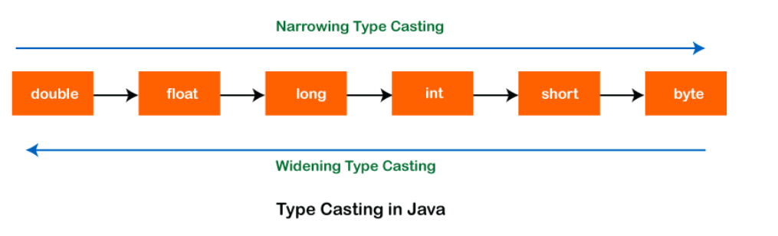

Code:-
public class typeCasting {
public static void main(String chndn[]) {
int a = 78;
double b = a;// Automatic casting int to double
System.out.println(b);

// manually casting double to int

double d = 98.25;
int e = (int) d;
System.out.println(e);

char ch = 'A';
int cha = (int) ch;
System.out.println(cha);
}

}

